SIMATS ENGINEERING
ASSESSMENT TOOL 3 – Assignment 2

COURSE NAME: STATISTICS WITH R PROGRAMMING COURSE CODE: ITA04
COURSE OUTCOME COVERED

CO3: Construct and manipulate data frames using reshaping, merging, and file I/O operations in R to prepare structured datasets for analysis.. (BL3, BL5)

Assessment Tool Weightage: 20%

QUESTIONS: 5 Total Marks: 100

Annexure

Assignment 2

Code of Conduct:

I _M.SADHANA[192524386](Name / Reg No) certify that this submission is my original work and that I have adhered to the guidelines specified for this assessment.
I understand that any violation of academic integrity rules will result in disciplinary action.

Signature of the student:

Assignment 2:
- Generate 5 Questions for your Capstone Project module
- Apply the formulae and use the relevant graph to visualize it
- Upload the file in Github link
- Save the 5 Questions and Gihub link in the Excell sheet

CO3 AT3 - Assignment 2

NAME: M. SADHANA

REG NO:192524386

COURSE CODE:ITA0408

COURSE NAME: STATISTICS IN R PROGRAMMING

DATE: 28/10/2026

MODULE 3 — INTERACTIVE DASHBOARD AND EARLY- WARNING SYSTEM

Question 1 — Dashboard Development
Develop an interactive R Shiny dashboard to display the total number of students, average academic score, average attendance, and at-risk students using a student performance dataset.
Formulas used:
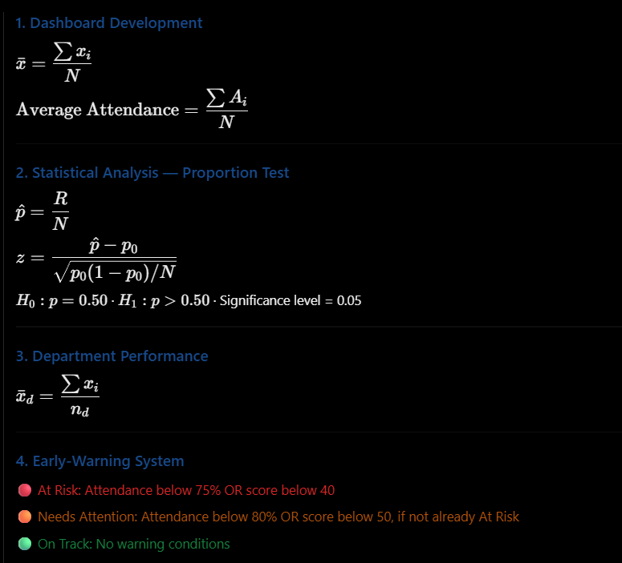
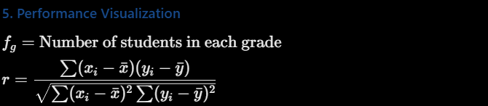

Code:
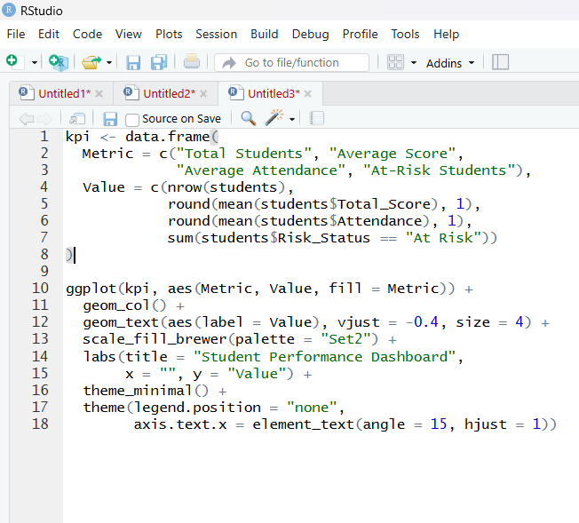

Graph:
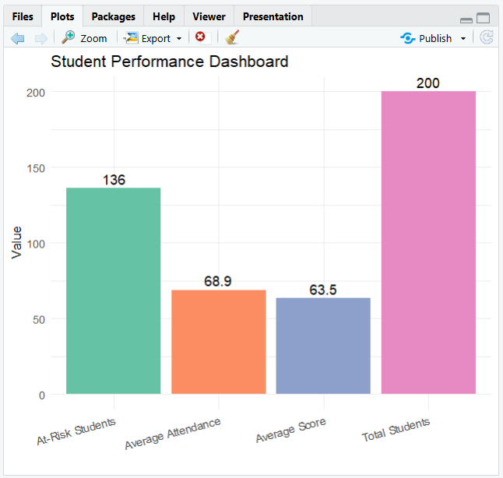

Question 2 — Statistical Analysis
Perform a one-sample proportion test to determine whether the proportion of at-risk students is significantly greater than 50%. State the null hypothesis, alternative hypothesis, p-value, and conclusion.
Formulas used:
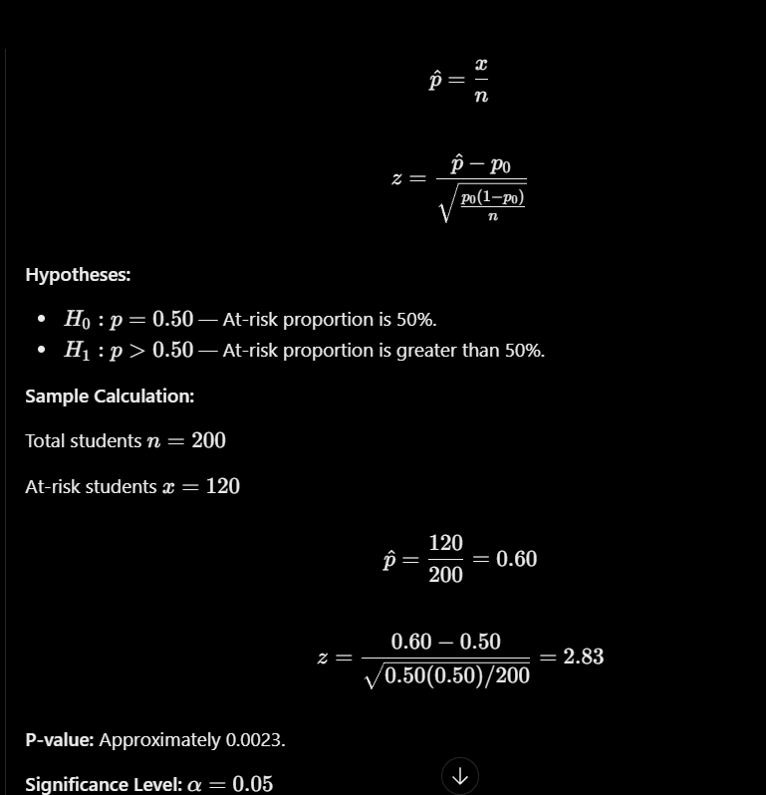

Code:
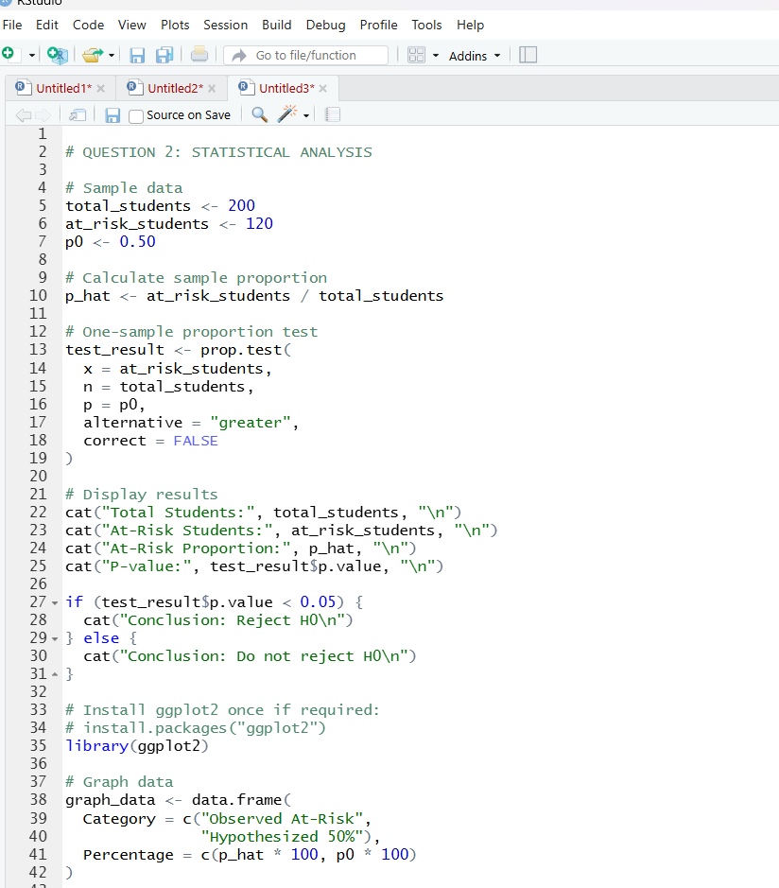
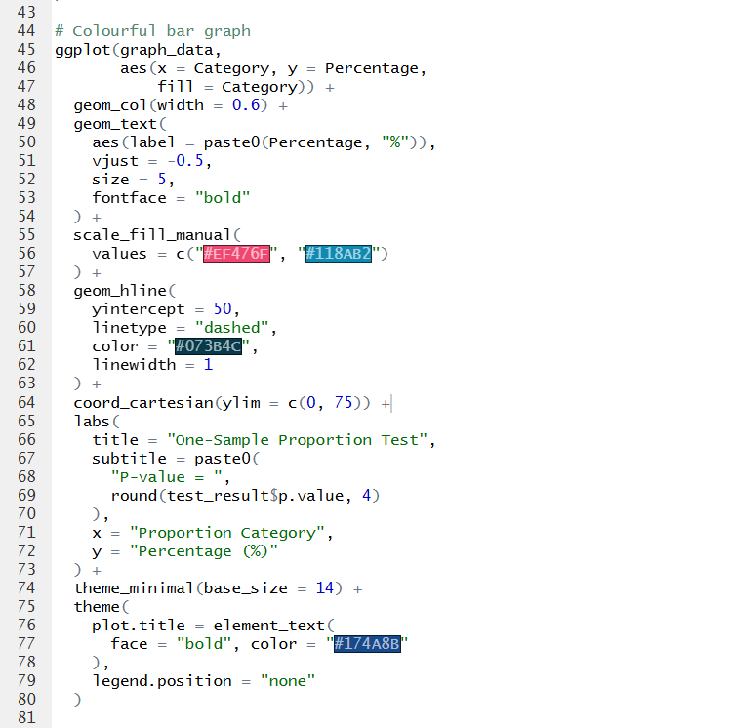
Graph:
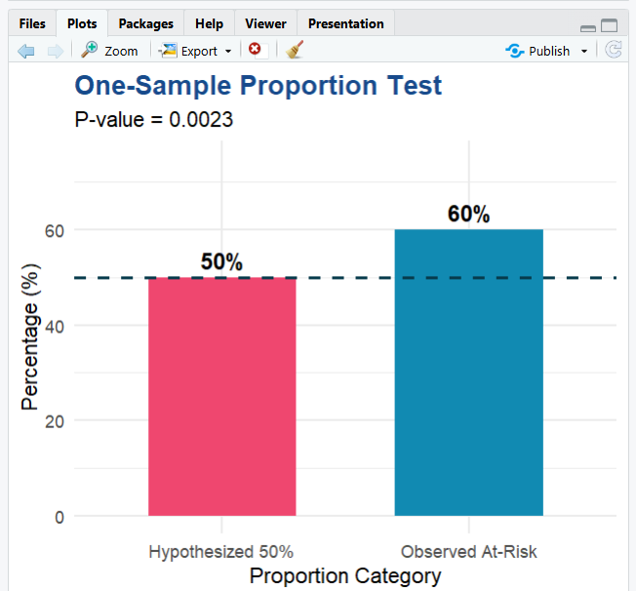

Question 3 — Department Performance
Calculate the mean academic score for each department and create a colourful bar graph to compare departmental performance.
Formulas used:

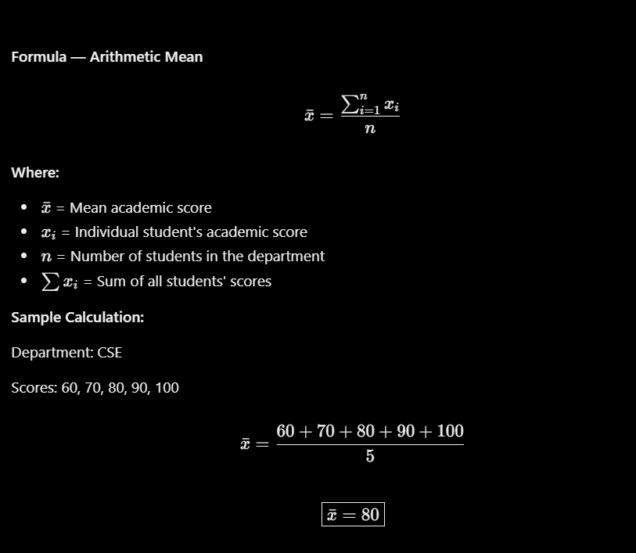

Code:
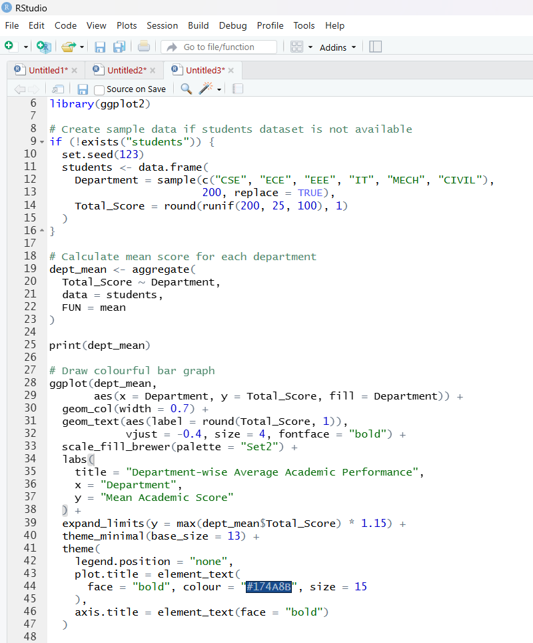

Graph:
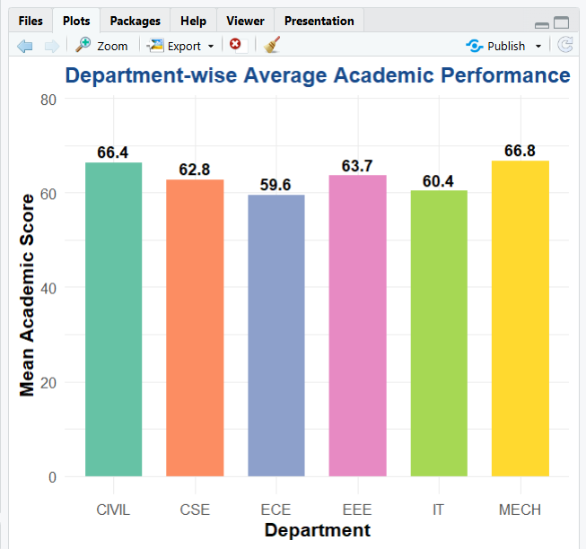

Question 4 — Early-Warning System
Classify students into At Risk, Needs Attention, and On Track categories based on attendance percentage and total score. Display the number of students in each category.
Formulas used:
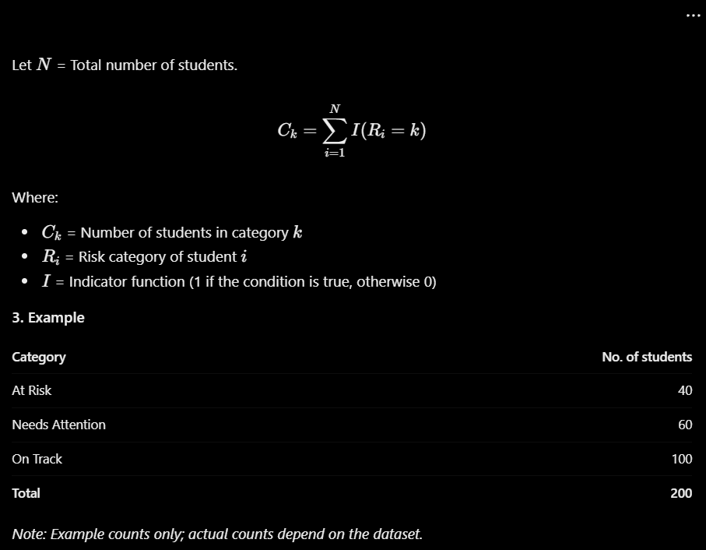

Code:
: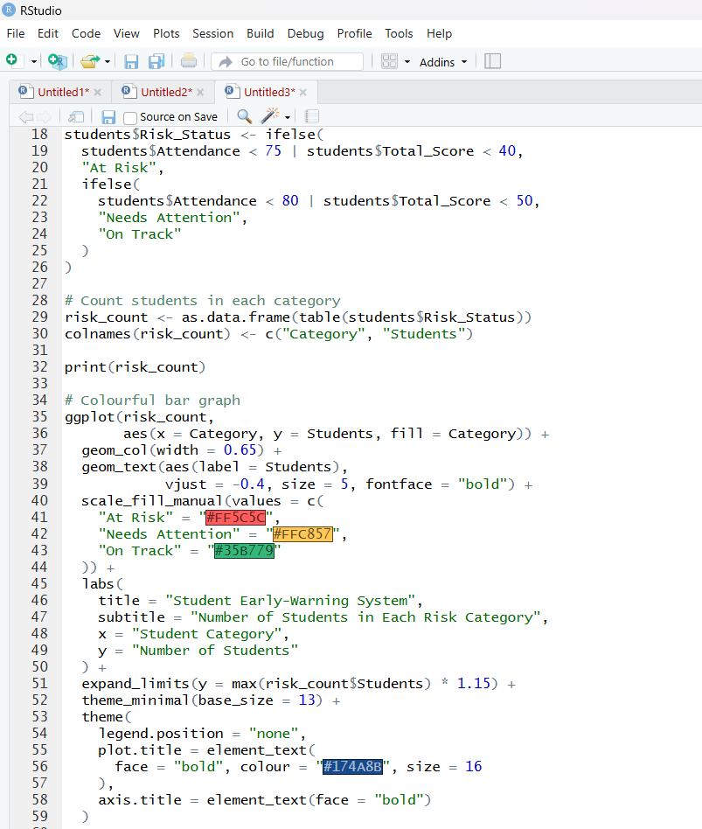

Graph:
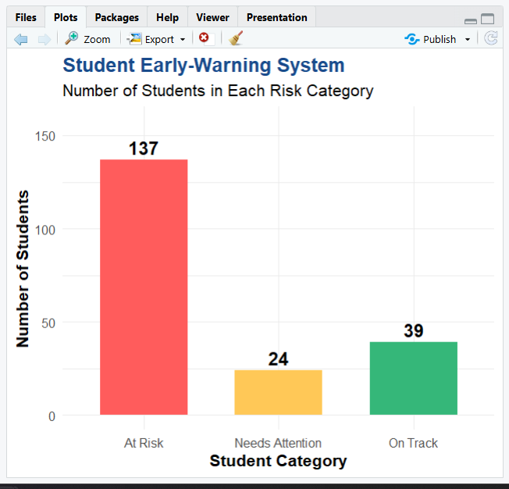

Question 5 — Performance Visualization
Create a grade-distribution graph and an attendance-versus-total-score scatter plot. Explain how these visualizations help identify students who may need academic support.
Formulas used:
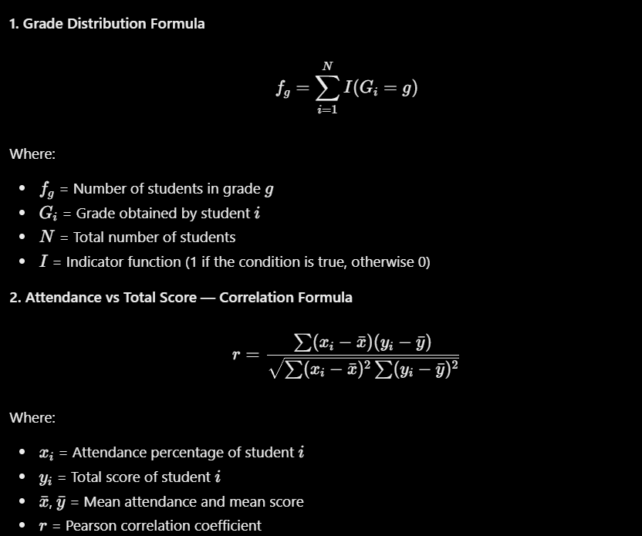

Code:

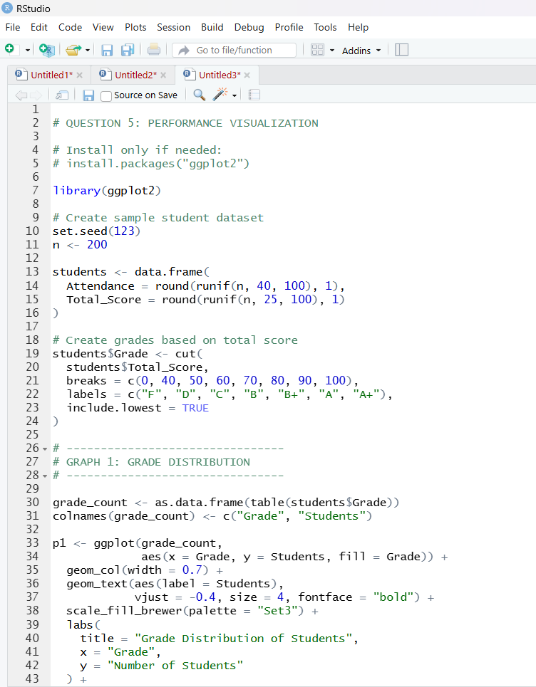

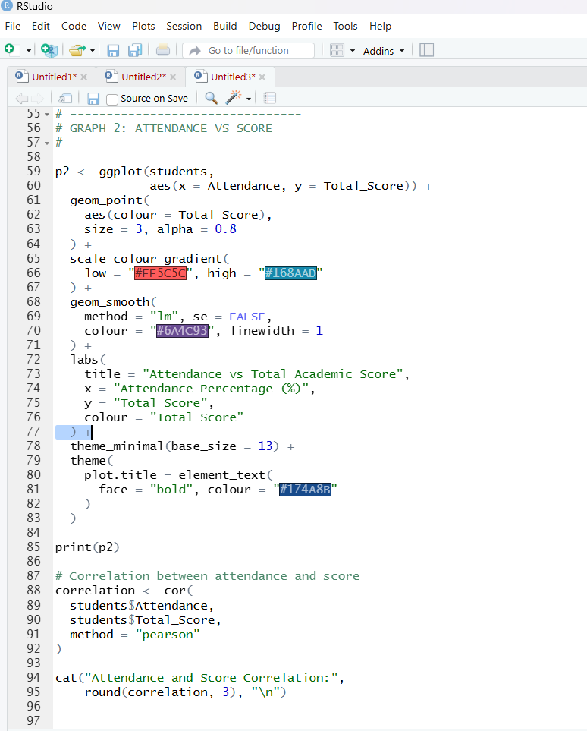

Graph:
